Travis Moore

GAT330 — Fall 2016

Professor: Jen Sward

**­**

Homework Assignment #5  
Non-verbal Game Analysis

Describe what and how the designer communicates a "story" (relationships, story, situation, etc.): (characters, levels, mechanics, etc.)

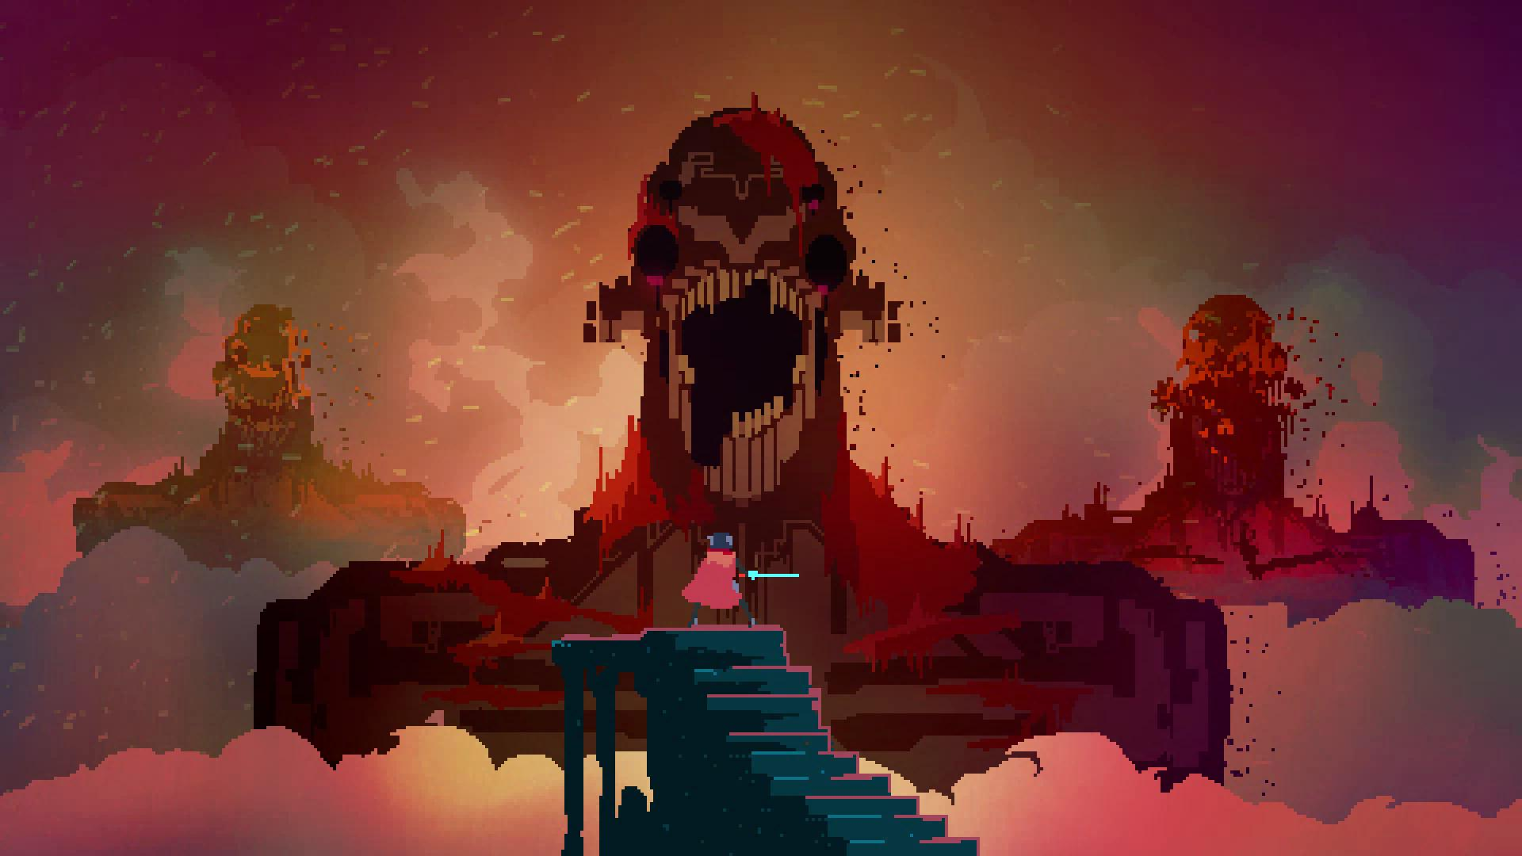

The opening cinematic

*Hyper Light Drifter* is a 2D Action RPG with a 16-bit aesthetic and modernized mechanics and design. To draw comparisons from other games, *Hyper Light Drifter* is heavily inspired by games like *The Legend Of Zelda: A Link To The Past* and *Dark Souls*. In *Hyper Light Drifter* you play as a sword and pistol wielding drifter who wakes up after surviving what appears to be an apocalyptic attack with a horrible malady that causes the player to occasionally cough up bright pink blood with troubling frequency. The opening cinematic is cryptic, dreamlike, and the most information you’ll ever outright receive in the game. After this scene you set out upon the world trying to piece together what happened to the world and to yourself.

There is no written narrative or voice acting in the game to tell you the story in *Hyper Light Drifter*, instead the game makes extensive use of the environment to tell the story of the game. Every area of the game’s environment has a story to tell, with only a few NPCs in the game providing some context in the form of pictographs. The more you explore the varying environments, the more clues you get about what has happened here. As you explore dungeonesque areas and defeat bosses you unlock more pieces of the story by activating ancient technology. Each activation of the ancient technology seems to make the disease the player’s character has worse, passing the player’s character out and unlocking more information that was previously hidden from the introduction cinematic.

What was most effective for YOU, and why?

I’m a huge fan of showing, not telling, so to me this was an extremely effective way to make me interested in a game’s story. By tying the narrative to the environment it made every new area like a treasure hunt for more clues. I’m not usually someone to play games for a story, but this method of unveiling a narrative visually is highly addicting, if art heavy. I appreciated the ability of tying the narrative to the mechanics of exploration, rewarding my exploration with something much better than simply new things to look at.

What was NOT effective for YOU, and how/what would you do differently to get the same effect?

Due to the game being very visually heavy in order to tell the story it became difficult at times to tell what were accessible areas and what was not accessible. I spent a lot of time in a few areas of the game trying to find a way to get somewhere that looked like it would be accessible when it wasn’t. Due to this, I would make sure that the visual language that dictates what is and isn’t viable ground is consistent from the start of the game. Aside from this, I would also be more generous with the UI that involves the in-game map. I fear that it is intentionally obscure in order to force the player to explore in order to find accessible areas. This created moments of frustration where it looked like there were more areas to explore that I just couldn’t get to. While it might decrease some of the difficulty in finding new areas, I feel like an accurate UI in-game map would help more than it would take away from the satisfaction of finding secret areas.